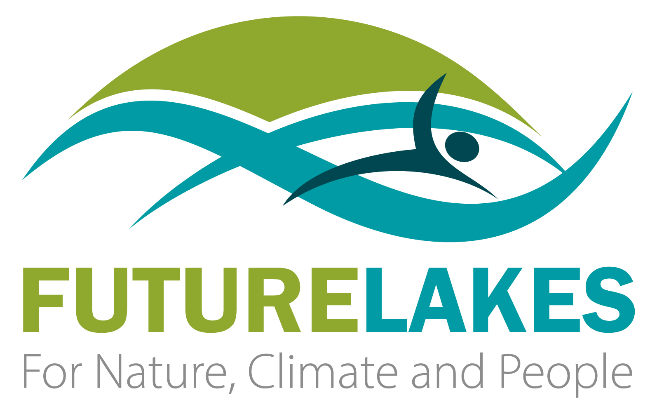

Call for Associated Regions
  - Application Form

Publication Date: 31.01.2025

Instructions for the application form
All proposal documents must adhere to the following formatting guidelines:
Font and Size
Use Arial for the main body text, consistently applied throughout the document. Body text should be a minimum of 11 points, including within tables. Headers, footnotes, endnotes, captions, and formulas may use a smaller, legible size.
Spacing
Use single line spacing with a minimum of 6 pt paragraph spacing, including text in tables.
Page layout
Proposals must be set to A4 page size with at least 15 mm margins on all sides.
Page limit
The page limit is indicated for each section of the application form. The overall proposal is limited to a maximum of 10 pages, including all tables, figures, references, and supplementary content. Content exceeding 10 pages will not be reviewed.
File format
Submit proposals in PDF format only.
Language Requirements
English is the official language for the FutureLakes Open Call for Associated Regions. All applicants should have a proficient command of English. Proposals in other languages will not be considered. English will also be the project’s official language for all communications, reports, and deliverables.
Proposals that do not meet these formatting and language requirements will be considered ineligible for evaluation.
The final application should be sent by e-mail to futurelakes@niva.no by 31.03.2025, 17:00 CET

Additional required documents
A scanned copy of an originally signed document confirming the legal status of the grant recipients must be provided at the time of application submission.
A letter of commitment from each member of the consortium.

Please delete the first cover page and this page when submitting the proposal, along with any guidance paragraphs highlighted in grey italics on the following pages

FutureLakes Call for Associated Regions - Application Form

General Information
Title of Project | <e.g. Restoration of Lake XXXX, or Restoration of Lakes in XXXX Region>
Location of your associated region | - Country:  - Region/Province/County:  - River basin (if relevant):  - Municipality (if relevant):
Legal name of the lead organisation | <Local or regional authority name>
PIC code of lead organisation
Website (optional)
Contact details of person representing the lead organisation | - Name and surname:  - Function:  - Email contact:
Contact details of official with legal responsibility for the lead organisation | - Name and surname:  - Function:  - Email contact:
Name(s) and PIC code(s) of any partner organisations
Expected start date | <no later than 30th September 2025>
End date (fixed) | 30th September 2027

- Participants
Name(s) of any partner organisations and contact details.

- Suitability of region
Maximum 2 pages.
Description of lake(s) in region, their current state (e.g. Water Framework Directive status; Biodiversity status), and the challenges you face in restoring them (pollution, degraded natural habitats, biodiversity loss, algal blooms, invasive species, impoverished communities, risks to water security, etc.).
Describe previous actions applied to restore the lake(s) (if any).
Describe current goals of restoration for the site (if any exist).
Describe who is currently responsible for managing lakes in your region and any other stakeholders actively involved in lake monitoring and management.
Describe past and current uses of the lake(s) and any existing plans or proposals for developing future use.
Provide online links for any websites or publications that provide more information (no more than 3 links).

- Relevance to FutureLakes
Maximum 1 page including table.
Explain why you think the challenges faced by your lake/region are relevant to the FutureLakes project objectives. Indicate if you think any specific innovations that FutureLakes is testing are relevant, or any particular measures that have already been demonstrated at our Demo sites. Also indicate if there are any WP tasks that are of particular high interest to you.
Complete the table below ranking which FutureLakes objectives are highest priority for your lake/region. Rank from 1 to 6, ranking 1 for your highest priority to 6 for your lowest priority. This ranking is for the FutureLakes management board to consider what FutureLakes activities may be most relevant.
FutureLakes Objective / Mission Goals | Rank
Improving ecological and chemical status of your lake
Restoring biodiversity in and around your lake
Enhancing the Blue Economy in and around your lake
Engaging the public in lake monitoring or management activities
Making society more resilient to climate change
Establishing circular economies through recovering resources from lake sediments or lake biota

- Impact
Maximum 1 page.
What do you estimate the impact you hope to achieve (1) regionally and (2) nationally will be? In particular, describe any activities that you could undertake using the FSTP grant that could help publicise the FutureLakes solutions to other lakes across your region/country.
What are the capacity needs of your region/country in relation to lake protection and restoration? Are there any specific areas of knowledge or expertise that your region/country need to strengthen?
Additionally, outline if there is any expertise or experience that you can provide to the FutureLakes consortium to further enhance the impact of our project on our objectives and the goals of the MISSION Restore our Ocean and Waters.

- Implementation
Maximum 1 page.
Please describe what existing resources (human, technical, financial, institutional) you have at your disposal in your organisation/consortium to develop the action plan and roadmap and also for future implementation of proposed measures.
Outline any past or existing activities undertaken for co-creation of lake basin management or restoration plans with regional stakeholders. Outline any future opportunities for regional engagement activities that could be supported using the FSTP grant to co-develop an action plan for your lake. Please consider the milestones for draft (October 2026) and final plans (May 2027) when outlining the timing of engagement and co-creation activities.
Are there any known barriers to implementing restoration measures at your lake(s) e.g. private ownership of lake(s)/shorelines, or unwillingness of key landowners/farmers in the catchment to consider new solutions.

- Budget
Please provide a breakdown of your organisation’s planned budget (max. total EUR 54,000).
Please break down the planned effective use of the lump-sum. Any sub-contracting costs should be specifically described and justified
TOTAL BUDGET | EUR
Personnel costs
Subcontracting costs
Travel and subsistence¹
Attendance at all-partner meeting: Poland (X no. of people attending)
Attendance at all-partner meeting: Netherlands (X no. of people attending)
Other FutureLakes site visit/workshop costs
Regional travel costs
Equipment
Other goods, works, services (e.g. stakeholder meeting costs)
Indirect costs
Total eligible costs (max. 54,000)
¹Include costs for attending two all-partner FutureLakes meetings in Poland (2026) and Netherlands (2027). We recommend also including costs to visit one FutureLakes demonstration lake of most relevance to your region as well as costs for meeting stakeholders in your region/country.

- Consent to participate
By submitting this form, you give your consent to participate in this FutureLakes call for associated regions.
☐ I give my consent to the processing of my personal data, as described in section 8 of the Application Guidelines on data protection.
For proposals with multiple applicants (consortium):
☐ I declare to have the explicit consent of all applicants on their participation and on the content of this proposal

___________________________________________________
Name and signature, date and place

The following additional documents should be provided with the application:
- A letter of commitment from each member of the consortium.
- A document signed with QES confirming the legal status of all participating applicants.
- A Declaration on Honour (template provided on https://www.futurelakes.eu/calls) for all participating applicants, signed with QES

Disclaimer
FutureLakes is funded by the European Union under Grant Agreement Number 101156425. Views and opinions expressed are however those of the author(s) only and do not necessarily reflect those of the European Union or European Commission. Neither the European Union nor the granting authority can be held responsible for them.

